Subject: Computer Laboratory II: UI /UX Design (417526)

Experiment No. 1(Group A)

Aim: Design user persona for the users of selected product / system.

Outcome: At end of this experiment, student will be able to design a persona for any given product.

Theory :
What is a user persona?
A user persona is a semi-fictional character based on your current (or ideal) customer. Personas can be created by talking to users and segmenting by various demographic and psychographic data to improve your product marketing.
Why we need user personas:
User personas are extremely useful to grow and improve a business: they help uncover the different ways people search for, buy, and use products, so you can focus your efforts on improving the experience for real people and use cases.
What should a user persona consist of?
A simple persona, answers the following questions:
- Who are you?
- What’s your main goal?
- What’s your main barrier to achieving this goal?
Who are they?
You’re looking for details like “B2C marketer who works for a large company” or “office admin who manages digital and print correspondence,” which sum up a lot about your persona’s perspective when it comes to choosing and using your product.
What are their goals?
This is so you can understand how your product/service actually fits into your users’ and customers’ lives. Why are they buying/using it? What job are they trying to get done with it, what problem are they trying to solve?

What are the barriers preventing them from achieving their goals?
Now that you know who your users and customers are and what they are trying to accomplish, there’s one more thing to find out: what is stopping them from buying your product, or using it more often/better/more expertly?

How Do You Make a User Persona?

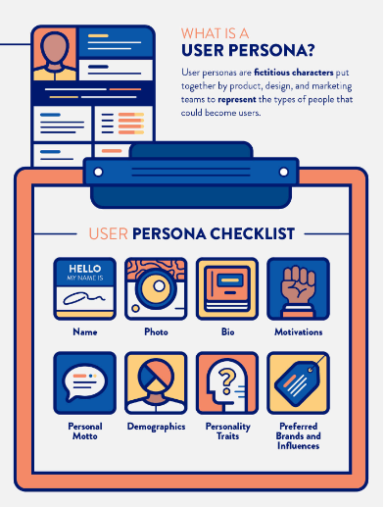
- Name: User personas should feel like a real person. Giving them a name is the first step. Avoid general denominations like “John Doe” or “Sally the Thrifty Shopper.”
- Photo: You always want to put a face to a name. Some companies choose to use fictional characters and celebrities as their persona photo but we advocate against this in order to create a new and original identity that’s free of stereotypes or preconceived traits.
- Personal motto: Just like a photo, this helps build out your persona to make them feel more realistic.
- Bio: Everyone loves a good back story. Give your persona a little history. Where did they grow up? Why did they choose their current job? How do they spend their free time? Include some details that help make them unique.
- Demographics: Of course, you’ll want to target users with specific interests, wants, and needs, rather than your perception of those things. Including demographics will help improve your understanding of and relationship with users, so you can relate to them in the way they want.
- Personality traits: Does your persona have a short attention span? Are they cautious? Do they make impulsive decisions? Assigning personality traits might help you understand if you need faster site designs or the option to comparison shop.
- Motivations: The goal is to get inside your user’s head and understand how they think. More importantly, what motivates them to use your product?
- Goals and frustrations: While the scope of a persona’s goals and frustrations should directly relate to your business needs, it’s worth highlighting goals that your persona may have outside of those your product or service directly impacts.
- Preferred brands and influences: You can learn a lot about a person by diving into brands they like and influencers they follow. Chances are the marketing tactics used by these brands and influencers will likely apply to you as well — allowing you to craft your outreach accordingly.

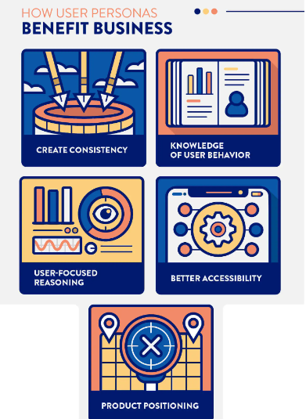

Create consistency across the business: User personas offer a company-wide understanding of your users, putting everyone on the same page. Across the board, personas create a consistent and specific understanding of each target group of customers within your company.
Signal user behavior: By gaining insight into the backgrounds of user personas, you’ll have a better understanding of where your real users spend their time, where they obtain information, and which social networks they thrive in. This information allows you to target and promote your products or services in places where they will actually be seen.
Help with user-focused reasoning: So, you and your team have brainstormed a service or offer that you think will be valuable to your users, but is it really something that they want? You might think your idea is genius, but what if you spend time brainstorming and it’s not something that’s actually in demand? User personas help eliminate wasted time and resources by clearly focusing on the needs of the user.
Improve design and development workflow: Not only do personas allow you to gain knowledge of user behavior and create consistency across your business, but they’re incredibly valuable in enabling design and product managers to create better products, services, designs, and UX. Better development guarantees your ability to suit the needs and preferences of your real users.
Define product positioning: Because you’ve utilized user personas in the brainstorm and developmental phases, you’ll be in a better place to position your product when it comes to promotion. User personas arm you with research to face the challenges and problems that come with product positioning.

Conclusion:

